Project Name: Jenkins S3 Disaster Recovery (JSDR)
Description: This project implements a backup and restore solution for Jenkins using AWS S3. This solution securely store Jenkins data in S3, automate backups, and facilitate a quick restore process in case of server failure.

Activities:
- Create a new server and install Jenkins
- Create freestyle jobs on the Jenkins server
- Create an S3 Bucket on AWS to store the backup of Jenkins directory

Create a new server and install Jenkins:
Create Server using cloud formation
Stack Name:
- Create Ubuntu image with
  - Image name : Server1
  - Image: ami-0ecb62995f68bb549 (ubuntu)
  - Instance: t2.micro
- Select key – “ProjectKey”. If this does not exists then create one
- Select security group – “Project-securityGroup”. If this is missing then create a new one in default VPC. Allow all inbound traffic.

Code
YAML | AWSTemplateFormatVersion: '2010-09-09'  Description: >  Create a t2.micro EC2 instance (Project-WP) using Ubuntu AMI with key  Parameters:  KeyPairName:  Type: String  Default: ProjectKey  Description: EC2 KeyPair name to use or create if missing.  DefaultVpcId:  Type: AWS::EC2::VPC::Id  Description: Select the default VPC where the instance will be created.  Resources:  # Create a key pair named ProjectKey (if it doesn’t exist)  ProjectKey:  Type: AWS::EC2::KeyPair  Properties:  KeyName: !Ref KeyPairName  KeyType: rsa  # Create a security group named Project-securityGroup in the default VPC  ProjectSecurityGroup:  Type: AWS::EC2::SecurityGroup  Properties:  GroupName: Project-securityGroup  GroupDescription: Allow all inbound traffic  VpcId: !Ref DefaultVpcId  SecurityGroupIngress:  - IpProtocol: -1  CidrIp: 0.0.0.0/0  # Create EC2 instance  EC2Instance:  Type: AWS::EC2::Instance  Properties:  InstanceType: t2.micro  ImageId: ami-0ecb62995f68bb549  KeyName: !Ref KeyPairName  SecurityGroupIds:  - !Ref ProjectSecurityGroup  Tags:  - Key: Name  Value: Server1  # ------------------------------------------------------------------  # MODIFICATION: Add BlockDeviceMappings to set the root volume size  # ------------------------------------------------------------------  BlockDeviceMappings:  - DeviceName: /dev/xvda # Standard root device name for Amazon Linux  Ebs:  VolumeSize: 16 # Set the size to 16 GiB  VolumeType: gp3 # Using gp3 is a modern, cost-effective best practice  DeleteOnTermination: true  # ------------------------------------------------------------------  Outputs:  InstanceId:  Description: Instance ID  Value: !Ref EC2Instance  PublicIP:  Description: Public IP address of EC2 instance  Value: !GetAtt EC2Instance.PublicIp  KeyPairUsed:  Description: Key pair used or created  Value: !Ref KeyPairName  SecurityGroupUsed:  Description: Security group used or created  Value: !Ref ProjectSecurityGroup

Screen shot
Clou Formation | 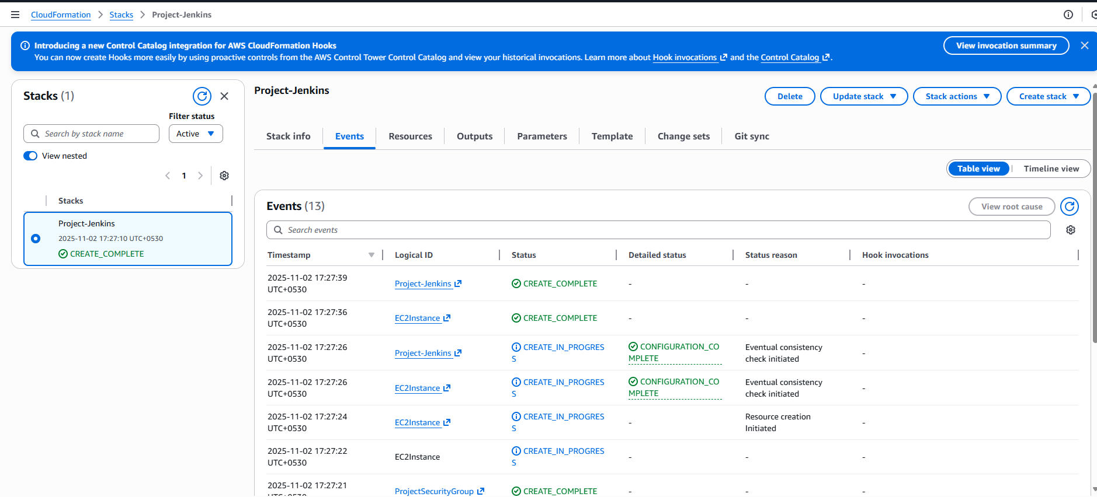
EC2 Instance
Connection | 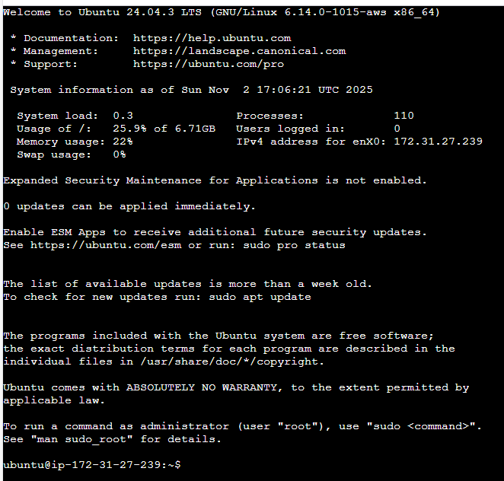

Create freestyle jobs on the Jenkins server
Install Jenkins  On Ubuntu VM | # 1️⃣ Update system  sudo apt update -y  # 2️⃣ Install dependencies  sudo apt install -y fontconfig openjdk-17-jre wget gnupg  # 3️⃣ Add Jenkins repo key  curl -fsSL https://pkg.jenkins.io/debian-stable/jenkins.io-2023.key | sudo tee \  /usr/share/keyrings/jenkins-keyring.asc > /dev/null  # 4️⃣ Add Jenkins repository  echo deb [signed-by=/usr/share/keyrings/jenkins-keyring.asc] \  https://pkg.jenkins.io/debian-stable binary/ | sudo tee \  /etc/apt/sources.list.d/jenkins.list > /dev/null  # 5️⃣ Update package index again  sudo apt update -y  # 6️⃣ Install Jenkins  sudo apt install -y jenkins  # 7️⃣ Enable and start Jenkins  sudo systemctl enable jenkins  sudo systemctl start jenkins  # 8️⃣ Check Jenkins status  sudo systemctl status jenkins  sudo cat /var/lib/jenkins/secrets/initialAdminPassword  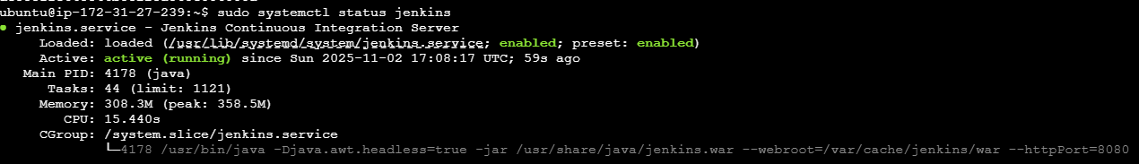
Login using public IP and install suggested plugins  Configure instance using private IP | http://54.227.174.71:8080  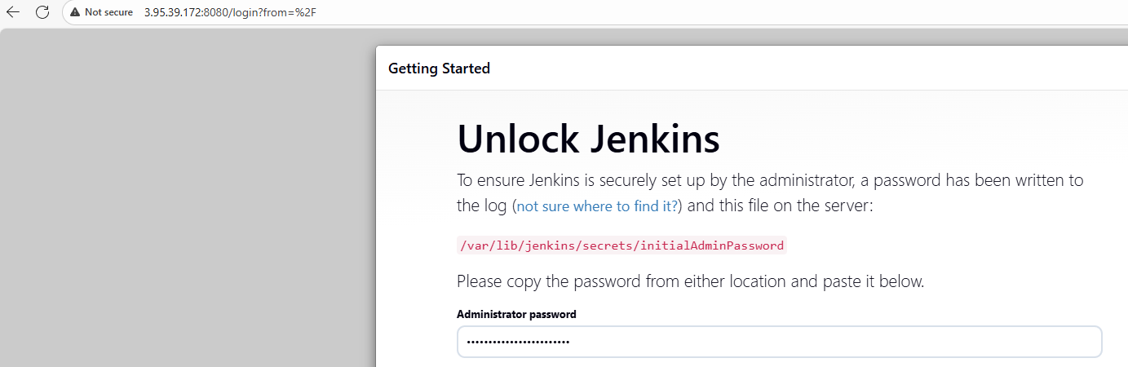 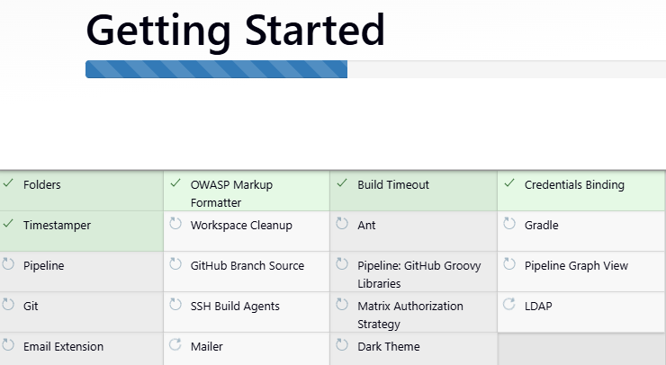 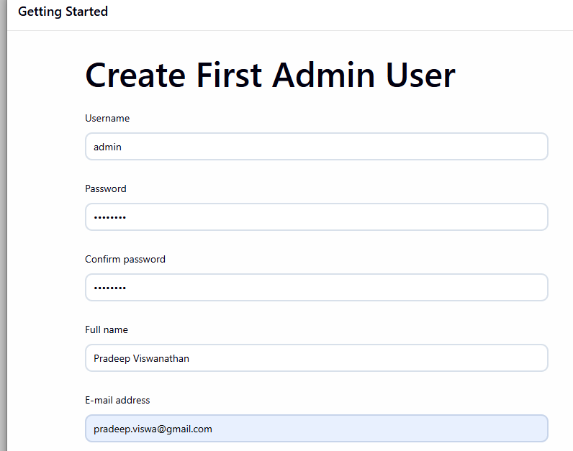 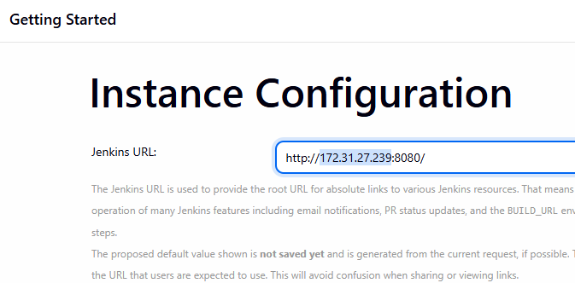
Install Maven | # 1. Go to /opt directory  cd /opt  # 2. Download Maven 3.9.9  sudo wget https://repo.maven.apache.org/maven2/org/apache/maven/apache-maven/3.9.9/apache-maven-3.9.9-bin.tar.gz  # 3. Extract the archive  sudo tar -xvzf apache-maven-3.9.9-bin.tar.gz  # 4. (Optional) Clean up the tar file  sudo rm -f apache-maven-3.9.9-bin.tar.gz  # 5. Create environment script for Maven  sudo tee /etc/profile.d/maven.sh > /dev/null << 'EOF'  export M2_HOME=/opt/apache-maven-3.9.9  export PATH=$M2_HOME/bin:$PATH  EOF  # 6. Make it executable  sudo chmod +x /etc/profile.d/maven.sh  # 7. Load the new environment variables  source /etc/profile.d/maven.sh  # 8. Verify Maven installation  mvn -version  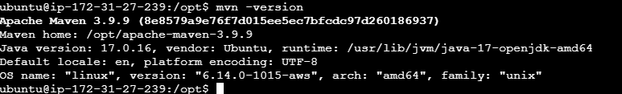
Global Tool Configuration | Open Global Tool Configuration  In the Jenkins dashboard:  - Click “Manage Jenkins” (left sidebar)  - Then click “Tools” or “Global Tool Configuration”  Configure JDK (Java)  a. Scroll down to JDK installations  - Click “Add JDK”  - Uncheck “Install automatically” (since we already installed manually)  - Give it a name, e.g. jdk-17  - In the JAVA_HOME field, enter your Java path: /usr/lib/jvm/java-17-openjdk-amd64  #Get java path  readlink -f $(which java)  /usr/lib/jvm/java-17-openjdk-amd64/bin/java  If you see /bin/java at the end, remove that part — keep only the directory up to amd64.  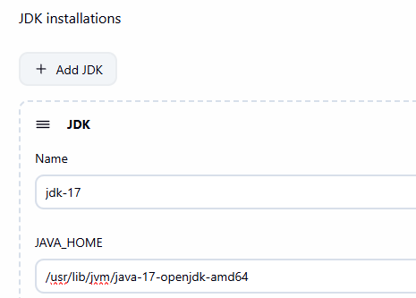  Configure Maven  a. Scroll down to Maven installations  - Click “Add Maven”  - Uncheck “Install automatically”  - Give it a name, e.g. maven-3.9.9  - In the MAVEN_HOME field, enter: /opt/apache-maven-3.9.9  Get this value from below command  mvn -version  Apache Maven 3.9.9 (8e8579a9e76f7d015ee5ec7bfcdc97d260186937)  Maven home: /opt/apache-maven-3.9.9  Java version: 17.0.16, vendor: Ubuntu, runtime: /usr/lib/jvm/java-17-openjdk-amd64  Default locale: en, platform encoding: UTF-8  OS name: "linux", version: "6.14.0-1015-aws", arch: "amd64", family: "unix"
Install Maven & Stage Plugins | Manage Jenkins Plugins Available Plugins  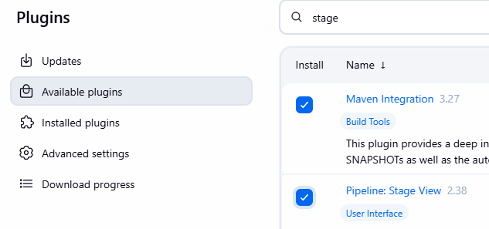
Create Freestyle project | New Item Freestyle project 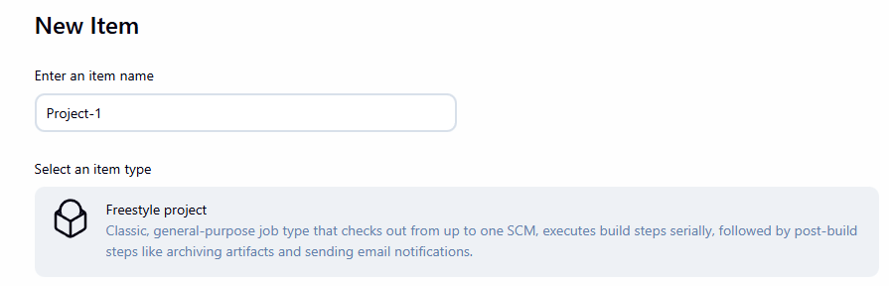 Triggers Poll SCM: * * * * * 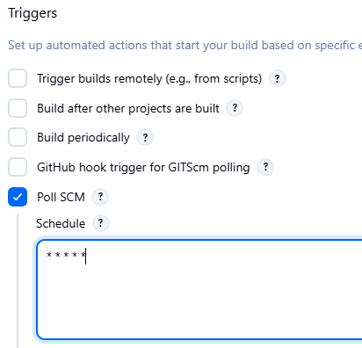 Source Code Management: https://github.com/pradeepviswa/MAVEN-SL-01-NOV-PROJECT.git 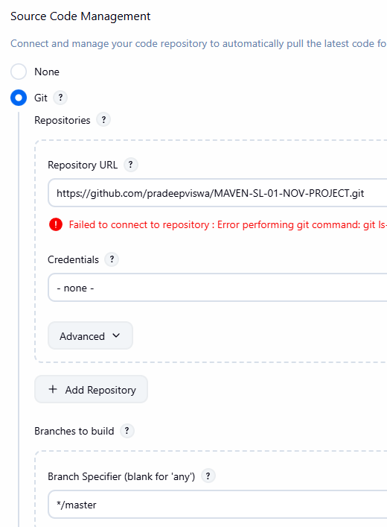  Build Steps Add Build Step: Invoke top-level Maven targets Goals: clean install 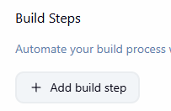 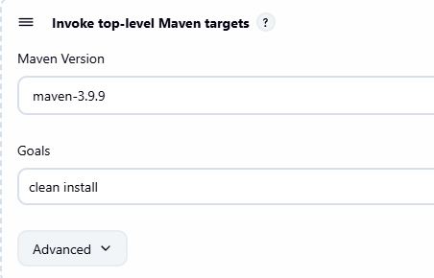 Build Steps Add Build Step: Execute shell Command: JAVA_HOME=/usr/lib/jvm/java-17-openjdk-amd64 PATH=$JAVA_HOME/bin:$PATH  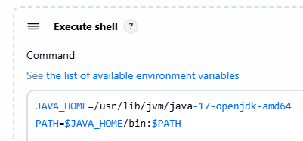  Build Now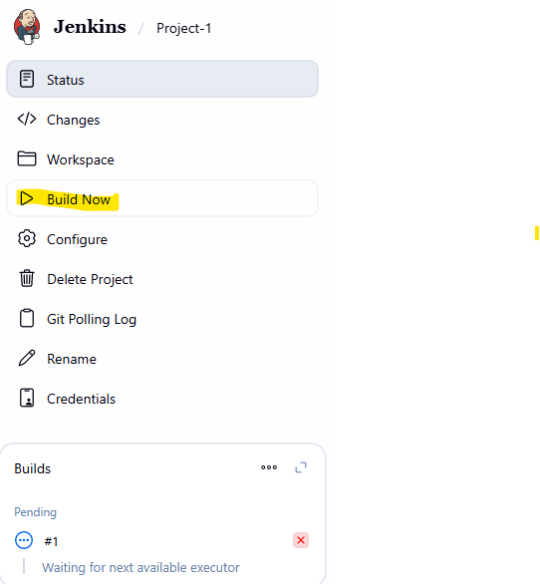 Build success! 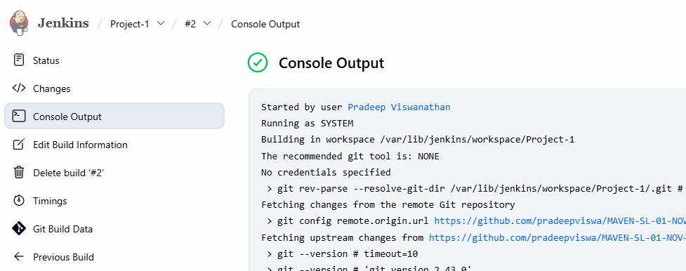

Create an S3 Bucket on AWS to store the backup of Jenkins directory
Some information about Jenkins log directory:
Jenkins saves internal log file here: /var/lib/jenkins
sudo find /var/lib/jenkins/jobs -type f -name log | head -5
see log of current project: sudo cat /var/lib/jenkins/jobs/Project-1/builds/2/log

Create a S3 bucket
S3 create bucket
Unique name of bucket: project-1-jenkins-log
Enable ACLs
Bucket Versioning: Enable
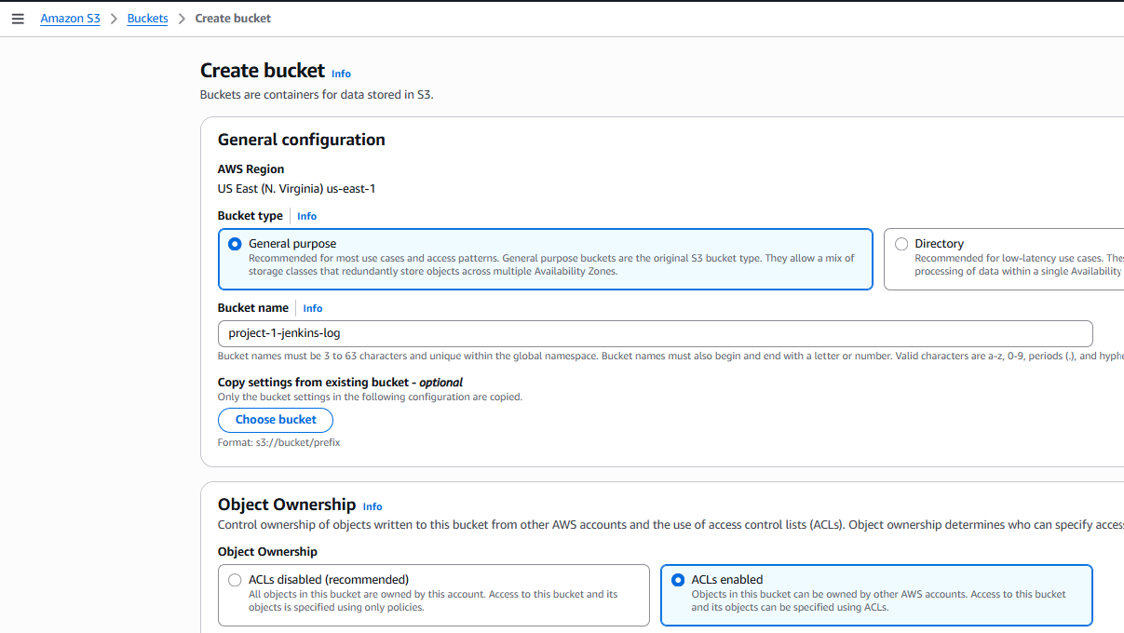
Create a new role for S3
IAM Roles Create Role (button)
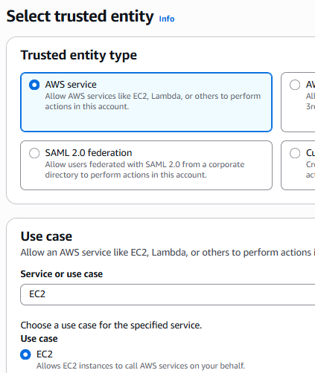 | AmazonS3FullAccess  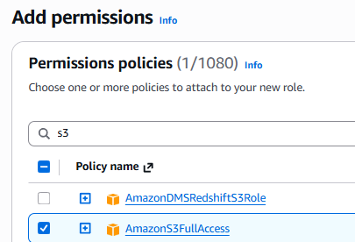 | Role name: ec2-full-access  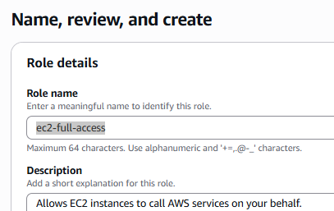

Map ec2-full-access role with VM
Select VM actions security Modify IAM role
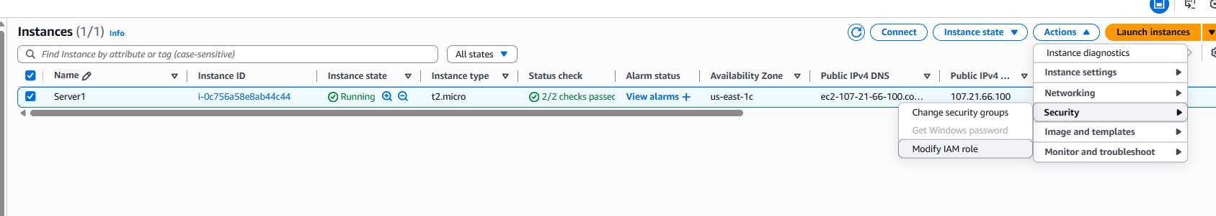

Select role and click on Update IAM role button
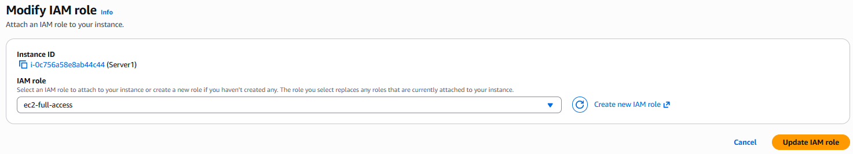

Install AWS CLI on ubuntu
#sudo apt install awscli -y #this is for ubuntu OS
cd /tmp
curl "https://awscli.amazonaws.com/awscli-exe-linux-x86_64.zip" -o "awscliv2.zip"
sudo apt install unzip -y
unzip awscliv2.zip
sudo ./aws/install
If you don’t already have access key then generate it from
- IAM Users <Username> Security Credential (tab) create access key (button)
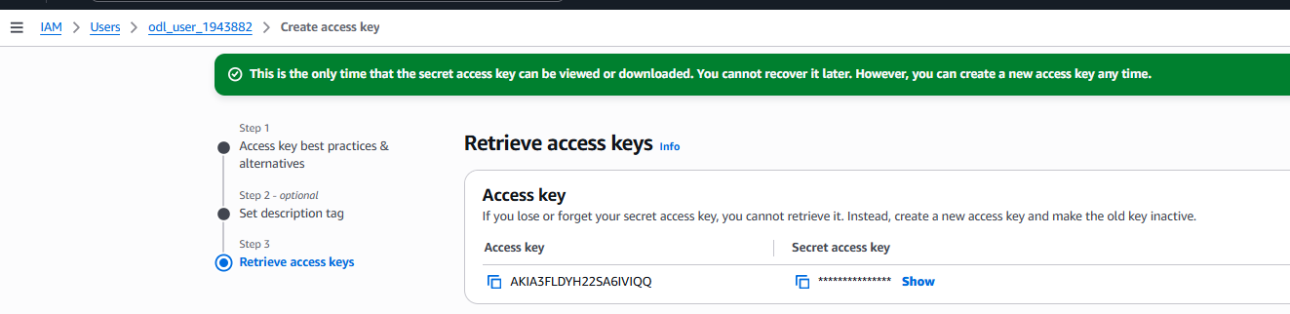
Login to AWS
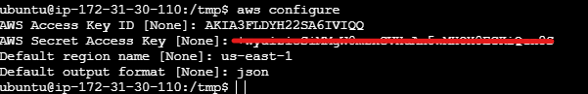
Run command: aws s3 ls
S3 bucket will be visible
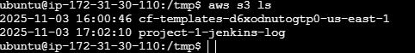
#it returns your IAM user or role
aws sts get-caller-identity
#Create a local log directory for Jenkins
sudo systemctl edit jenkins

#Then add this override:
[Service]
ExecStart=
ExecStart=/usr/bin/java -Djava.awt.headless=true -jar /usr/share/java/jenkins.war --webroot=/var/cache/jenkins/war --httpPort=8080
StandardOutput=append:/var/log/jenkins/jenkins.log
StandardError=append:/var/log/jenkins/jenkins.log 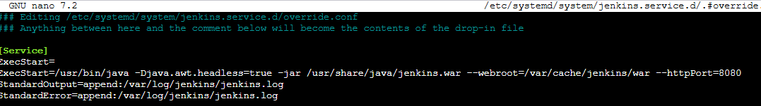

sudo mkdir -p /var/log/jenkins
sudo chown jenkins:jenkins /var/log/jenkins

#Save and reload
sudo systemctl daemon-reexec
sudo systemctl daemon-reload
sudo systemctl restart jenkins

#verify jenkins is up
sudo systemctl status jenkins -l

#check log file is being written properly
sudo tail -f /var/log/jenkins/jenkins.log

#create a cron job
sudo crontab -e
# press 1 if prompted for
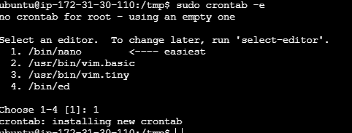

# add this line, this will write log file to s3 bucket every minute.
* * * * * aws s3 sync /var/log/jenkins/ s3://project-1-jenkins-log/jenkins_service_logs/ --storage-class STANDARD_IA && aws s3 sync /var/lib/jenkins/jobs/ s3://project-1-jenkins-log/jenkins_job_logs/ --exclude "*workspace*" --storage-class STANDARD_IA

Explanation:
- The first sync uploads Jenkins service logs
→ s3://project-1-jenkins-log/jenkins_service_logs/
- The second sync uploads all job build logs (deployment logs)
→ s3://project-1-jenkins-log/jenkins_job_logs/
- --exclude "*workspace*" skips large build folders.

In AWS, open S3 bucket, jenkins log file is visible
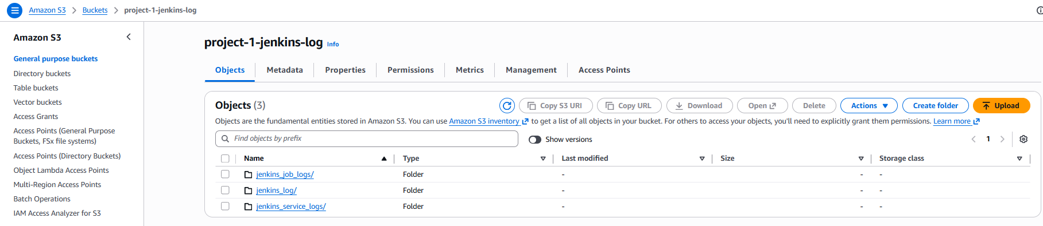

Build Logs:
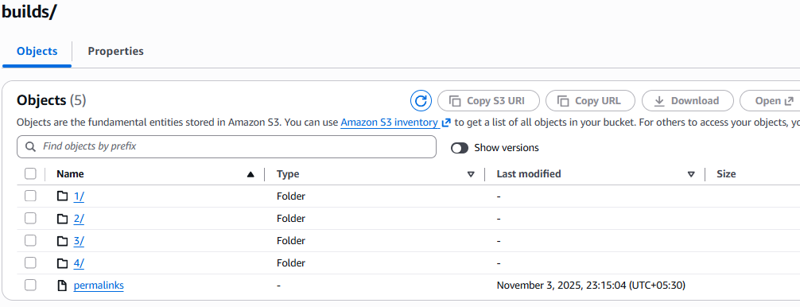
Access logs from EC2 server:
Commands:
aws s3 ls s3://project-1-jenkins-log/
s3://project-1-jenkins-log/jenkins_job_logs/Project-1/builds/
aws s3 cp s3://project-1-jenkins-log/jenkins_job_logs/Project-1/builds/1/log - | cat

